***Minutes for week two 22/09/2014***

An email was received from JK, it stated

Tomas, I read the proposal and there are certainly the makings of a clear idea in there but I think you need to elaborate a bit on what happens once the group is formed. Creating a working private forum to direct the tasks are tricky and maybe not the right way to go. Have a look at Trello to see something very successful in the space you propose. Maybe create your own clone? Rgds, J

From this we decided to flesh out what happens after a group is formed so ideas where:

* John mc Gowan suggested a calendar based system. Instead of the forum for the group, a calendar would be used to keep track of what was done.EG; I got this done on the 24th of September. This can be used to send reminders of deadlines as the whole group will get a notification of this via the interface.
* Greg Sheerin suggested two comments systems, one for milestones (I got this done today) and one for issues (I can’t get X part working).

We decided to replace the forum system with the former as will be far more intuitive as some users may not be comfortable with a forum.

We then began to discuss the layout of the site. Since we were already discussing the layout of the calendar we decided to do a rough layout of the calendar.

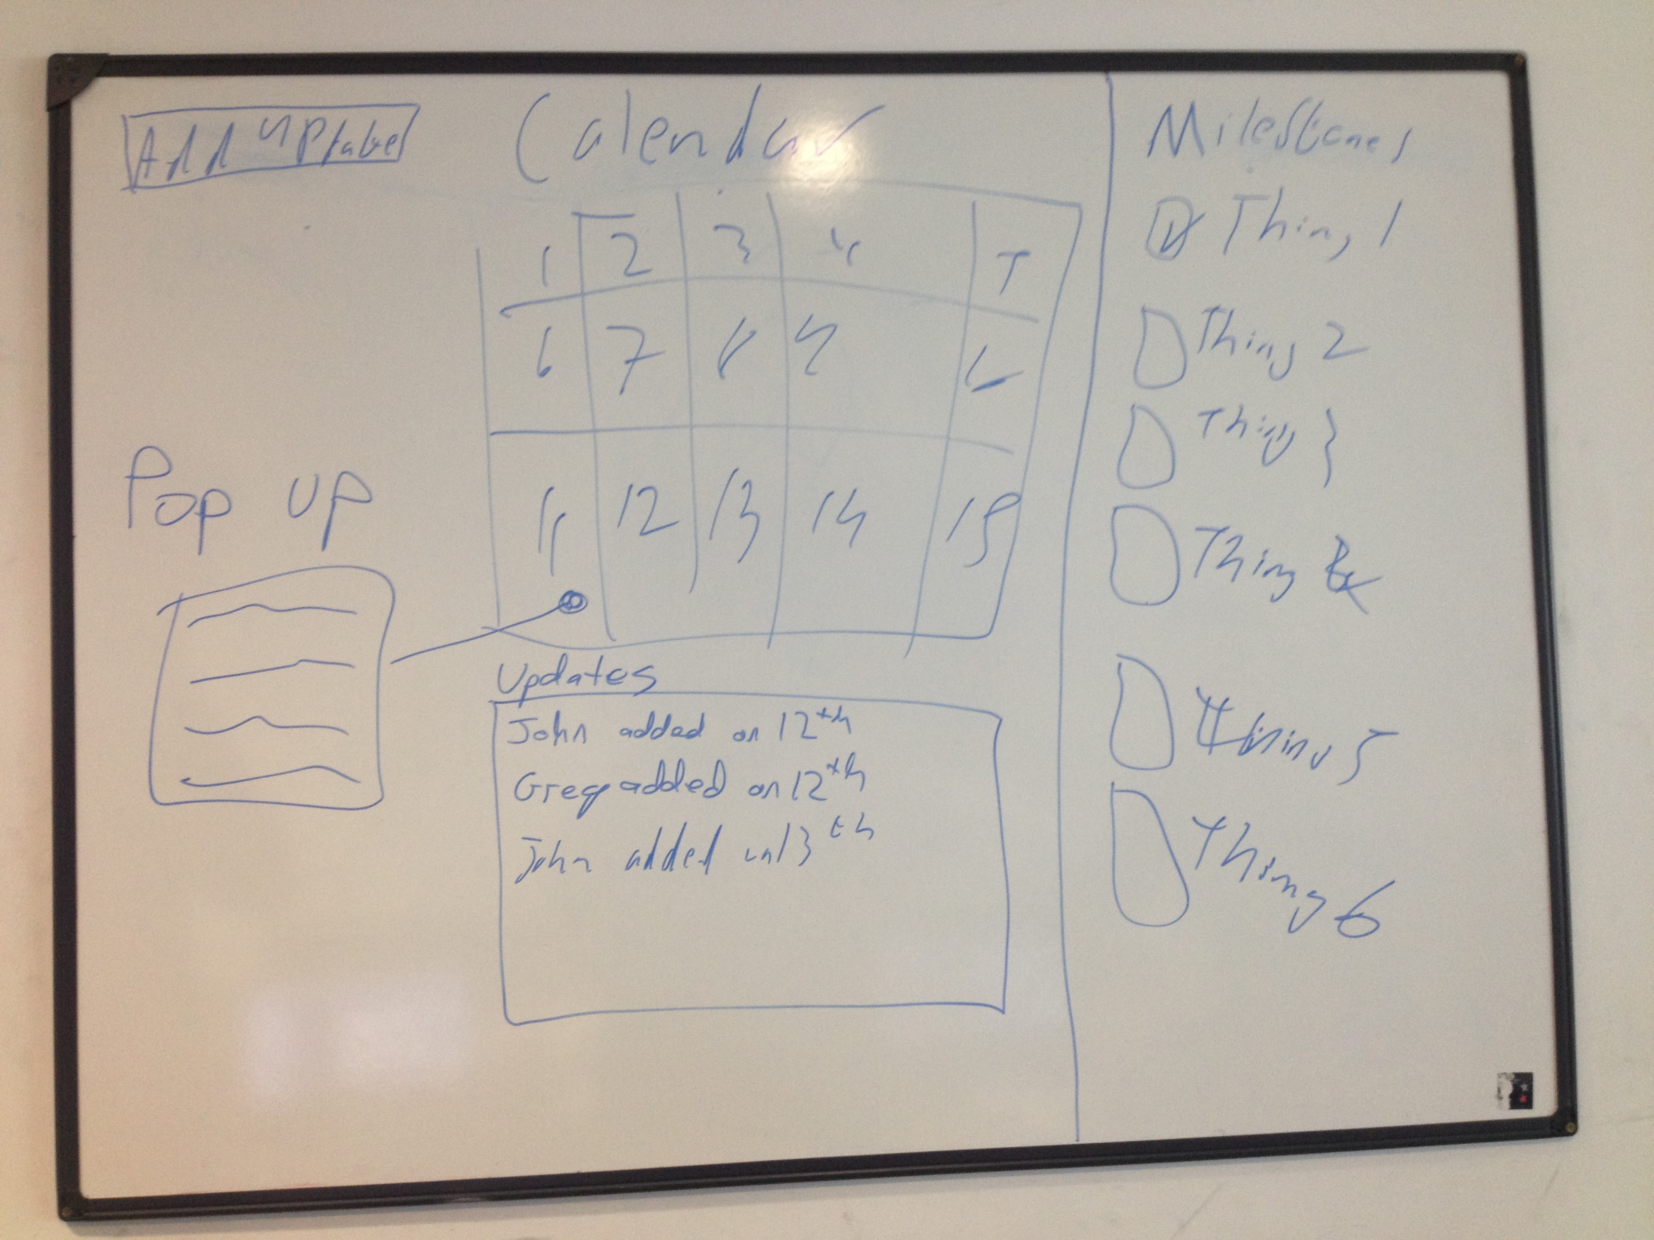

This is a very rough idea of what we want the calendar page to look like. With this design we hope that users will find it easy to understand and pick up.

After this we began to discuss setting up file sharing systems for the project.

For this week we decided that:

* Tomás will set up a github repository for use of the group
* Greg will set up a drop box for storage of files, photos and any other no code material
* John will continue his work on design, fleshing out the layout of the site
* Cormac will research an interactive calendar that will work for this page.